API Rules

**Tables Excluded:**

common_notes

companies

company_project_types

contacts

dashboarddata

debug

emailnotifications

files_index

filing_cabinet_tabs

filing_cabinet_tabs_members

forum_watch

modules

queries

report_companies

report_groups

reports

roles

rotas

star_application

star_readings

star_stages

stars

syskeys

sysvals

task_dependencies

tickets

user_preferences

user_roles

user_tasks

API Rules

**Tables Included:**

departments

events

files

file_categories

forum_messages

forums

grouping_members

groupings

info_messages

permissions

project_tags

projects

report_instance

task_access_log

task_log

task_log_archive

task_xmlform_approvers

tasks

tasks_archive

training

training_attendees

triggered_tasks

user_access_failed

user_access_iplist

user_access_log

users

xmlform

xmlform_restrictions

API Rules

**departments –**

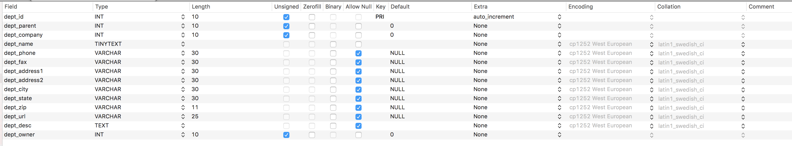

**Allowed methods –**

Create

Update

Show

List

API Rules

**events –**

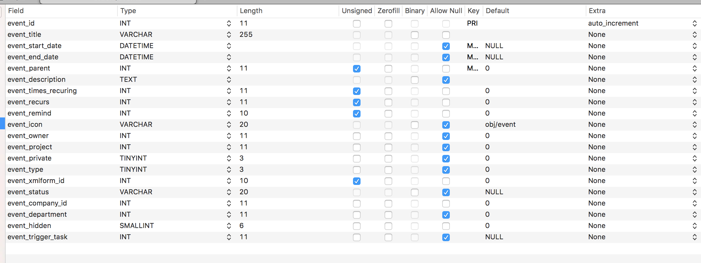

**Allowed methods –**

Create

Update

Show

List

Delete

API Rules

**files –**

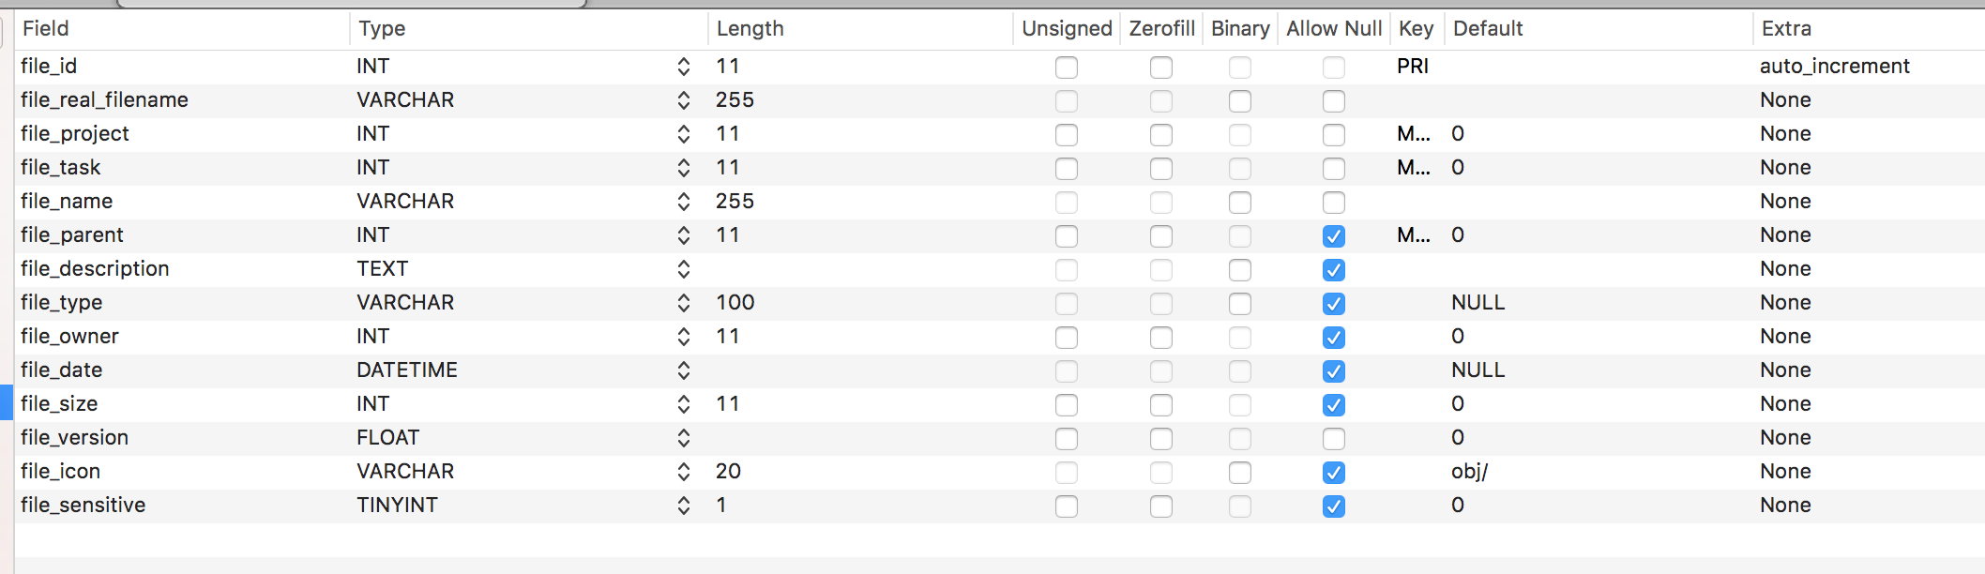

**Allowed methods –**

Create

Update

Show

List

Delete

API Rules

**file_categories –**

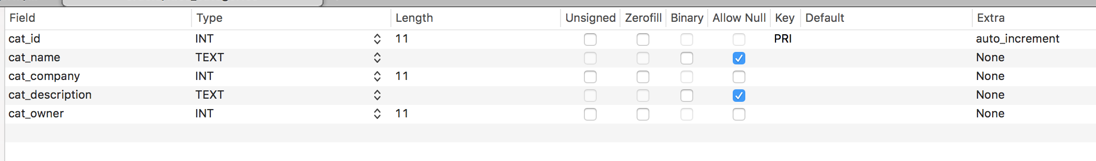

**Allowed methods –**

Create

Update

Show

List

API Rules

**forum_messages –**

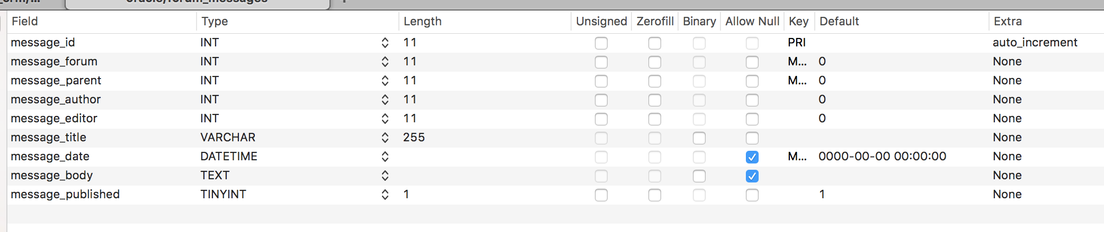

**Allowed methods –**

Create

Update

Show

List

Delete

API Rules

**forums –**

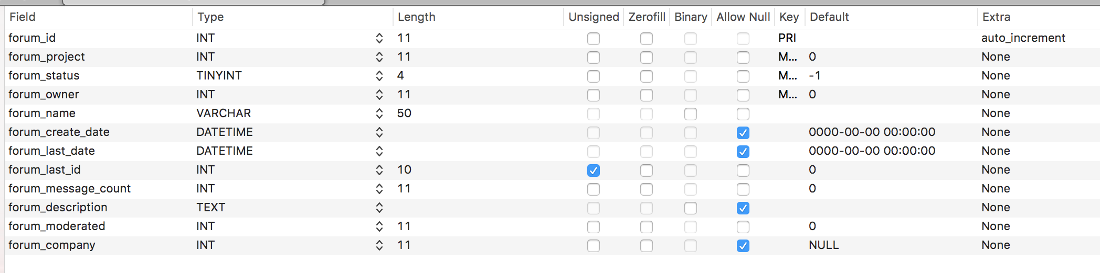

**Allowed methods –**

Create

Update

Show

List

API Rules

**grouping_members –**



**Allowed methods –**

Create

Update

Show

List

Delete

API Rules

**groupings –**

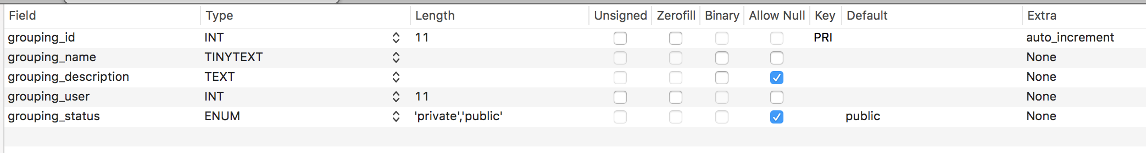

**Allowed methods –**

Create

Update

Show

List

API Rules

**info_messages –**

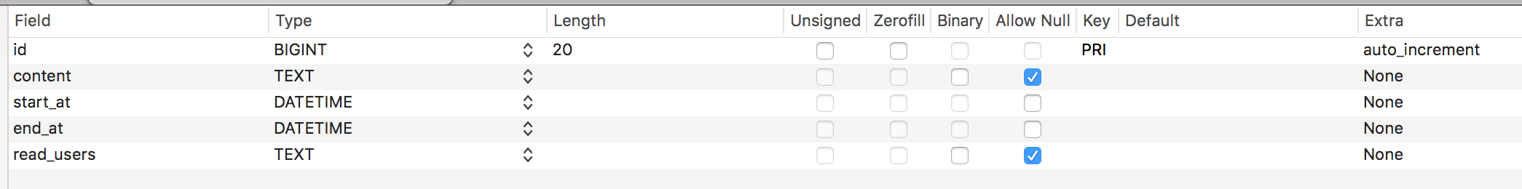

**Allowed methods –**

Create

Update

Show

List

Delete

API Rules

**permissions –**

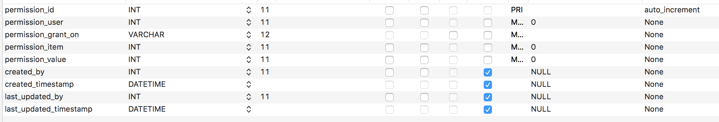

**Allowed methods –**

Create

Update

Show

List